**SOTD (Spirit of the Deal)**

* login as thaymore(we can directly login) direct url

select "show : Deals Referncing You as AM/CAM approved deals" and "Filter by deal status : Approved(active)"

here we are trying to reopen NS approved deal

DealID: 103112165

Deal Name:test quote

*Instead of loging into SFDC if we login to CCW

whatever NS deals that we see here those will be dealType-5

*If we see in CCW UI(thaymore UI):

NON-STANDARD STATUS is "APPROVED",to see NS status in backend then it will be in "cq_deal" table

so for that the query is

select * from cq_deal where opty_number='103112165'

we will have column MDM_DEAL_STATUS in table so that will be '7' and

DEAL_TYPE is '5'

to know what is 7 then the query is

select * from CQ_LOV where lov_type='MDM_DEAL_STATUS' (it doesn't show any data that means it must be with different name)

so to check that ,the query is

select * from cq_lov where lov_type like '%DEAL_STATUS%'

(PDR_DEAL_STATUS is quote status that will be in cq_quote table)

so here in cq-lov table the column name is "DEAL_STATUS"

so finally the query is

select * from CQ_LOV where lov_type='DEAL_STATUS'

so here we can see '7' means "approved"(This is how we can find NS deal status)

to know what is 5 then the query is

select * from CQ_LOV where lov_type='DEAL_TYPE' it is "PDR Collaborated Deal"

Its already approved so try to Re-Open the deal

After reopening we dont have to change anything

(There are some SOTD rules if we want we can go through it)

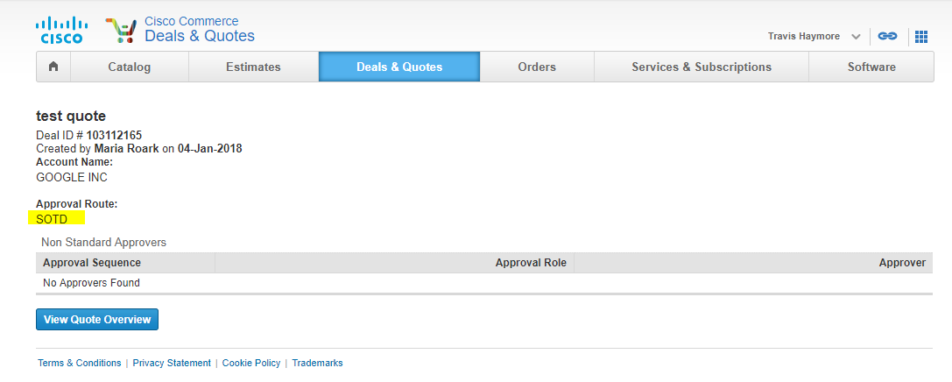

If we see above the NS Deal was automatically approved (Approval Route)

If we go to Quote Oerview and see Non Standard Status it will be approved

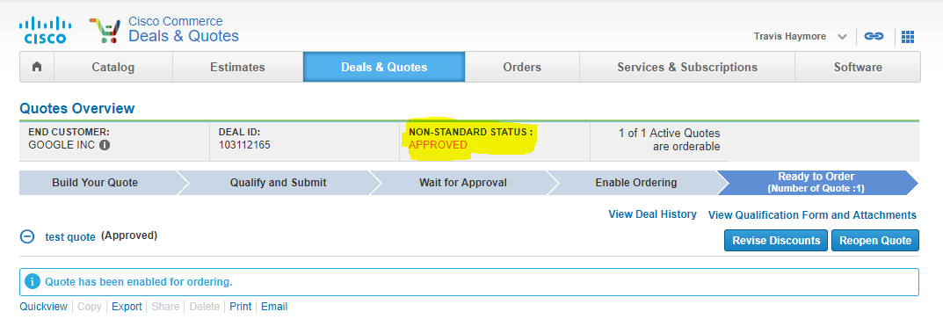

So this is SOTD(spirit of the deal)

now if we goto MDM

http://mdmui-cstg.cloudapps.cisco.com/mdmui/rest/proxyHome

Proxy User: duabhish

only NS deals will be visible,it will be either of dealType=2 or dealType=5

This is where we can directly approve it

This option will be there only if we login as "Abhishek Dube(duabhish)

he is super user

we can have options like

1.edit deal

2.executive summary

3.If we clicl on dealId we can have more Information,it will show "scenario browser"

In CCW we have quotes(Quote Number) for the deal,the same way in MDM for a deal we will have scenarios

what evr the quote we create in backend the values in cq_quote and cq_quote_line they copy it into MDM tables,

they are called cq_scenario and cq_scenario_line.so that quote become a scenario

In muti-quote scenario only one should be published.so the main scenario will be we have to check this i.e.,

Recommended Quote should be "true"

published should be "published"

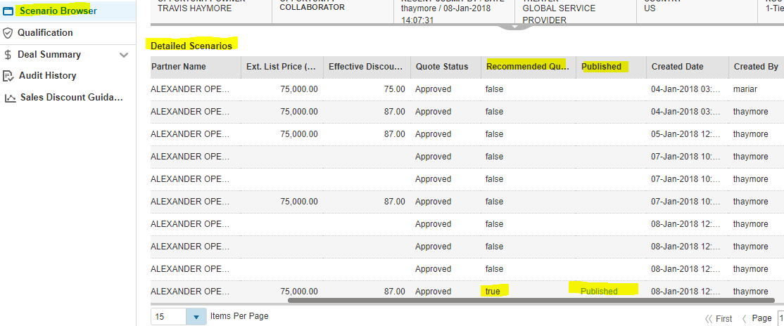

This will be the main scenario

We are getting the scenario browser data from following table

select * from cq_scenario where deal_object_id=4708966490

select * from CQ_LOV where lov_type='SCENARIO_TYPE'

“IS_STRINGENT” is a main column in cq_scenario table

If “IS_STRINGENT” is Y then Recommended Quote will be ‘true’ and published will be ‘published’

The MDM code will decide which one should be ‘Y’ usually scenario should be ‘Y’